French and Indian War DBQ

Directions: Question 1 is based on the accompanying documents. The documents have been edited for the purpose of this exercise.

In your response you should do the following:
- State a relevant thesis that directly addresses all parts of the question.
- Support the thesis or a relevant argument with evidence from all, or all but one, of the documents.
- Incorporate analysis of at least four documents into your argument.
- Focus your analysis of each document on at least one of the following: intended audience, purpose, historical context, and/or point of view.
- Support your argument with analysis of historical examples outside the documents.
- Connect historical phenomena relevant to your argument to broader events or processes.
- Synthesize the elements above into a persuasive essay that extends your argument, connects it to a different historical context.
- Develop and support a cohesive argument that recognizes and accounts for historical complexity by explicitly illustrating relationships among historical evidence such as contradiction, corroboration, and/or qualification.

Evaluate the extent to which the Seven Years’ War (French and Indian War, 1754-1763) marked a turning point in American relations with Great Britain, analyzing what changed and what stayed the same from before the war to the period after it.

Document 1

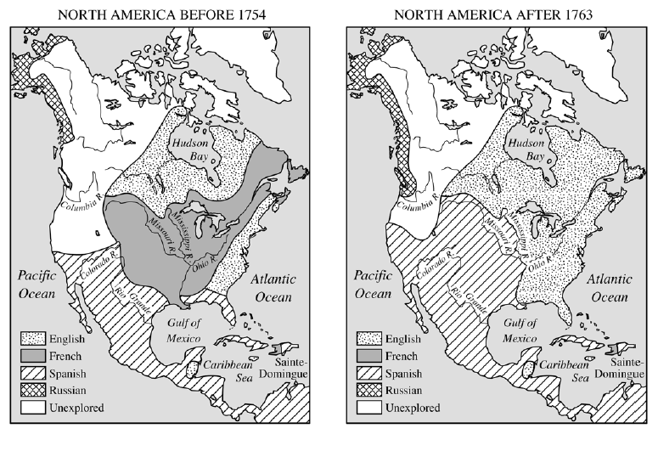
Document 2

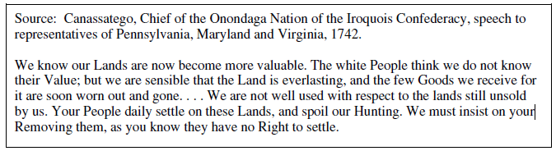

Document 3

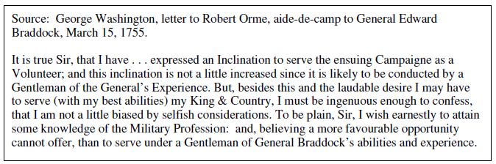

Document 4

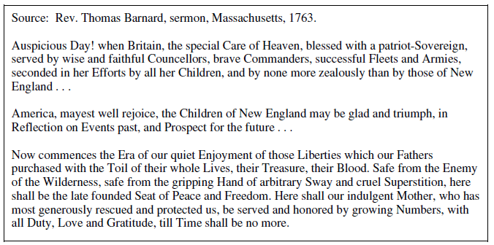
Document 5

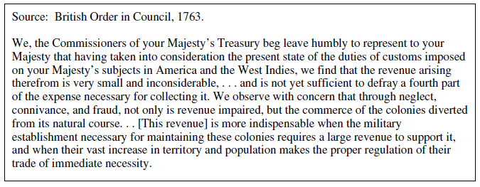

Document 6

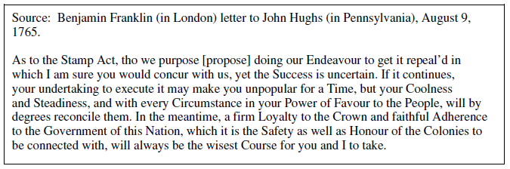

Document 7

